Implement a solution to the problem described below. Your work must include the following:
- Algorithm in pseudocode included in the java file that you are submitting
- Your version of the PostalCode.java
  - you must use the following:
    - Scanner – for the input
    - System.out.print or System.out.println for output
    - method matches for input validation
    - switch statement
  - include as many comments as are necessary to describe what the given code segment is doing
  - make sure that your code is formatted properly
- Output of your program that shows multiple runs that test various scenarios
- Please make sure to include your name in each file that you are submitting
BEFORE STARTING PLEASE READ THE PROBLEM DESCRIPTION AND THE INSTRUCTIONS CAREFULLY.
Problem Description
For faster sorting of letters, the United States Postal Service encourages companies that send large volumes of mail to use a bar code denoting the ZIP code:
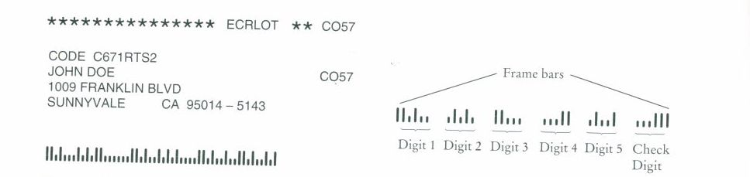
The encoding scheme for a five-digit ZIP code is shown below. There are full-height frame bars on each side. The five encoded digits are followed by a check digit, which is computed as follows: add up all digits, and choose the check digit to make the sum a multiple of 10. For example, the sum of the digits in the ZIP code 95014 is 19, so the check digit is 1 to make the sum equal to 20. Each digit of the ZIP code, and the check digit, is encoded according to the following table, where 0 denotes a half bar and 1 a full bar:

Digit | Mapping
1 | 00011
2 | 00101
3 | 00110
4 | 01001
5 | 01010
6 | 01100
7 | 10001
8 | 10010
9 | 10100
0 | 11000

Your Task
Write a program that asks the user for a nine-digit ZIP code in the form DDDDD-DDDD (for example 95014-5143) and prints the bar code. Use ‘:’ for half bars, and ‘|’ for full bars.

For example, 95014-5143 becomes
||:|:::|:|:||::::::||:|::|:|:|::::||:|::|::||:|::|:|
where last five bars represent the check digit. Note that the ‘-‘ is ignored.
The program validates the input. After converting the valid zip code to its bar code representation, asks the user if (s)he wants to convert another one.
Please note that the finished client and the skeleton of the service class have been provided so your task is to finishe the service class as per given UML diagram.
Sample Run of the program
Enter a ZIP code in the form DDDDD-DDDD
abcd
Your input is invalid, please re-enter
Enter a ZIP code in the form DDDDD-DDDD
123-456
Your input is invalid, please re-enter
Enter a ZIP code in the form DDDDD-DDDD
12345678
Your input is invalid, please re-enter
Enter a ZIP code in the form DDDDD-DDDD
12345-6789
.....The zip string to be processed is 123456789
.....The checksum is 45
.....The zip with the check digit is 1234567895

The zip code: 12345-6789 has the following bar code: |:::||::|:|::||::|::|:|:|::||::|:::||::|:|:|:::|:|:|

Would you like to generate another bar code?
yes
Enter a ZIP code in the form DDDDD-DDDD
95014-5143
.....The zip string to be processed is 950145143
.....The checksum is 32
.....The zip with the check digit is 9501451438

The zip code: 95014-5143 has the following bar code: ||:|:::|:|:||::::::||:|::|:|:|::::||:|::|::||:|::|:|

Would you like to generate another bar code?
yes
Enter a ZIP code in the form DDDDD-DDDD
93012-1211
.....The zip string to be processed is 930121211
.....The checksum is 20
.....The zip with the check digit is 9301212110

The zip code: 93012-1211 has the following bar code: ||:|::::||:||::::::||::|:|:::||::|:|:::||:::||||:::|

Would you like to generate another bar code?
No
Goodbye!

UML Diagram
